UNITED STATES
SECURITIES AND EXCHANGE COMMISSION
Washington, D.C. 20549

SCHEDULE 14A
Proxy Statement Pursuant to Section 14(a) of the
Securities Exchange Act of 1934
(Amendment No. )

Filed by the Registrant ☒ Filed by a Party other than the Registrant ☐
Check the appropriate box:

☐ | Preliminary Proxy Statement

☐ | Confidential, for Use of the Commission Only (as permitted by Rule 14a-6(e)(2))

☐ | Definitive Proxy Statement

☒ | Definitive Additional Materials

☐ | Soliciting Material under 14a-12
Aveanna Healthcare Holdings Inc.
(Name of Registrant as Specified in its Charter)

(Name of Persons(s) Filing Proxy Statement, if other than the Registrant)
Payment of Filing Fee (Check all boxes that apply):

☒ | No fee required.

☐ | Fee paid previously with preliminary materials.

☐ | Fee computed on table in exhibit required by Item 25(b) per Exchange Act Rules 14a-6(i)(1) and 0-11.


PROXY TABULATOR: P.O. BOX 8016, CARY, NC 27512-9903


Aveanna Healthcare Holdings Inc.
Annual Meeting of Stockholders
Friday, May 29, 2026 9:30 AM, Eastern Time
400 Interstate North Parkway, Suite 1600, Atlanta, GA. 30339

For a convenient way to view proxy materials, VOTE, and obtain directions to attend the meeting go to www.proxydocs.com/AVAH
To vote your proxy while visiting this site, you will need the 12 digit control number in the box below.
This communication presents only an overview of the more complete proxy materials that are available to you on the Internet. This is not a ballot. You cannot use this notice to vote your shares. We encourage you to access and review all of the important information contained in the proxy materials before voting.
Under United States Securities and Exchange Commission rules, proxy materials do not have to be delivered in paper. Proxy materials can be distributed by making them available on the Internet.
If you want to receive a paper or e-mail copy of the proxy materials, including the Proxy Statement, our 2025 Annual Report and proxy card, you must request one. There is no charge to you for requesting a copy. In order to receive a paper package in time for this year’s meeting, you must make this request on or before May 19, 2026. Please check the meeting materials for any special requirements for meeting attendance.
SEE REVERSE FOR FULL AGENDA

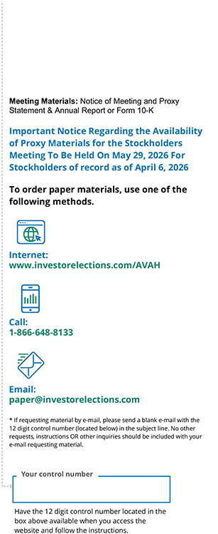
Copyright © 2026 BetaNXT, Inc. or its affiliates. All Rights Reserved

 |  | Aveanna Healthcare Holdings Inc. Annual Meeting of Stockholders

THE BOARD OF DIRECTORS RECOMMENDS A VOTE:
FOR ON PROPOSALS 1, 2 AND 3

 |  | PROPOSAL
1. |  | To elect the three Class II director nominees identified in the accompanying Proxy Statement to the Board of Directors of the Company, each to serve a three-year term expiring at the 2029 Annual Meeting of the Company’s stockholders.  1.01 Rodney D. Windley  1.02 Sam Weil  1.03 Steven E. Rodgers
2. |  | To ratify the appointment of Ernst & Young LLP as the Company’s independent registered public accountants for the fiscal year ending January 2, 2027.
3. |  | To approve, on an advisory, non-binding, basis, the compensation paid to the Company’s Named Executive Officers identified in the accompanying Proxy Statement.
4. |  | To consider any other business that is properly presented at the Meeting and any adjournment or postponement thereof.  NOTE: In the proxies’ discretion, the proxies are authorized to vote on any other matters, which may properly come before the Annual Meeting or any adjournment(s) or postponement(s) thereof.

